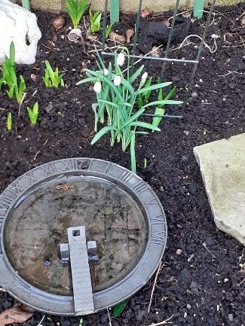
Thank you to Joan for this photo of snowdrops. Gardens have been battered by the storms and so has our Parish Centre - guttering came down bringing brickwork with it. At the time of producing this Newsletter, part of Selbourne Road has been closed off and the Parish Centre will not be used until it is deemed safe. Please pray for Revd Dave and Pauline as they seek solutions.
However, the spreading of the Gospel goes on and from 16th – 20th March a variety of activities are happening in our MISSION WEEK. There are sign up sheets in the church lounge so put your name down to help for any of those activities. For those not able to get out – please do pray that God will bless everyone involved and that people in our community here about Jesus and turn to Him, the One who gives life and hope. Come Holy Spirit !
Have you been worshipping at St. Thomas’ for 6 months, are you on our Electoral Roll? Please have a chat to Glenys (Cole) or Mike (Kilshaw)
SMALL GROUPS – launch evening on Wednesday 9th March 7pm in church for all those who have said that they would like to be involved.
Service schedule for the coming weeks:
Sunday 27thFebruary  Sunday before Lent | 10.30am Holy Communion with Prayer for Healing  Reading: Luke 10: 1 – 12  Theme: Being witnesses/Praying for healing  Leader/Celebrant: DOB Preacher: CB  6pm Prayer Gathering DOB/IL
Wed 2nd March  ASH WEDNESDAY | 11am BCP Holy Communion  Reading: Matthew 6 : 16 - 21  Leader: ES Celebrant: ES Preacher: DOB
Sunday  6th March  LENT 1 | 10.30am Service of the Word  Reading: John 1: 35 - 42  Leader: ES Preacher: YB  Theme: Being witnesses/Inviting others  6pm Prayer Gathering/Breaking of Bread SH/VB
Wednesday 9th March | 11am BCP Holy Communion  Reading: Luke 8: 4 - 15  Leader: ES Celebrant: DOB Preacher: YB
Sunday  13th March  LENT 2 | 10.30am Holy Communion FOCUS ON MISSION  Theme: Being witnesses  Leader/Celebrant/Preacher: TBA  6pm Prayer Gathering
Wednesday 16th March | 11am BCP Holy Communion  Reading: Matthew 15: 21 – 28  MISSION
Sunday  20th March  LENT 3 | 10.30am MISSION WEEK Service of the Word  Special guest: Pete Tomkinson – come and hear about being God’s Soldier  6pm Prayer Gathering/ Breaking of Bread

Our morning and evening readings for the coming week:
 | Morning Readings | Evening Readings
Monday 28th February | Psalm 80;  Genesis 37: 1 – 11;  Galatians 1 | Psalm 85;  Jeremiah 1;  John 3: 1 - 21
Tuesday 1st March  David, bishop, patron of Wales, c 601 | Psalm 89: 1 – 18;  Genesis 37: 12 – end;  Galatians 2: 1 – 10 | Psalm 89: 19 – end;  Jeremiah 2: 1 – 13;  John 3: 22 - end
Wednesday 2nd March  ASH WEDNESDAY | Psalm 38;  Daniel 9: 3 – 6, 17 – 19;  1 Timothy 6: 6 – 19 | Psalm 51;  Isaiah 1: 10 – 18;  Luke 15: 11 - end
Thursday 3rd March | Psalm 77,  Genesis 39;  Galatians 2: 11 – end | Psalm 74;  Jeremiah 2: 14 – 32;  John 4: 1 - 26
Friday 4th March | Psalm 3;  Genesis 40;  Galatians 3: 1 – 14 | Psalm 31;  Jeremiah 3: 6 – 22;  John 4: 27 - 42
Saturday 5th March | Psalm 97;  Genesis 41: 1 – 24;  Galatians 3: 15 – 22 | Psalm 104;  Jeremiah 4: 1 – 18;  John 4: 43 - end
(the LORD said…) Now my eyes will be open and my ears attentive to the prayers offered in this place.

