- Lord of comfort and peace, we ask that you be with all those who suffer pain and anguish in bereavement; and for all who are have are struggling with infirmity or pain in body, mind or spirit.

For those in hospital and at home;
surround the frightened with Your tenderness;
give strength to those in pain;
hold the weak in Your arms of love, and give hope and patience
to those who are recovering.

We bring before you now in Your healing power:

Sue, Sarah, Sheila, Jack, Leah, Marion, Louise, Debbie, Stephen, Ann, Mary & Keith, Irene, Nic & Joanne, Norman & Jean, Anne & Ian.

Thank you Jesus. Amen

Prayer Letter
Second Sunday of Easter

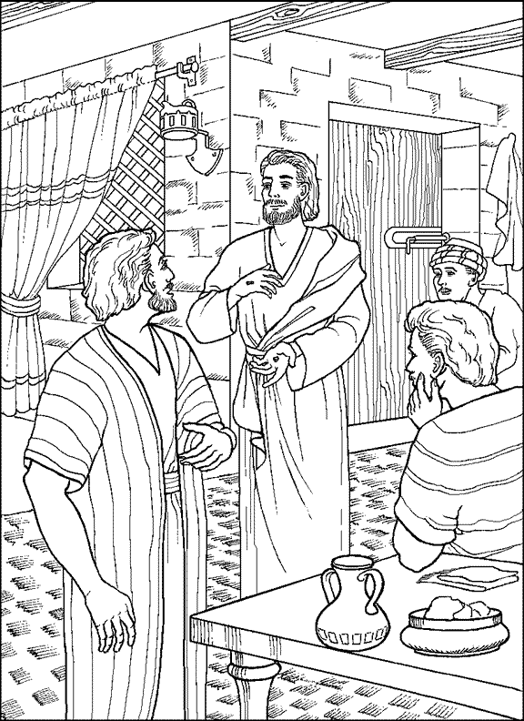
Blesed are those who have not seen yet have believed
Lord, pour out Your Holy Spirit upon us and may Your light so shine through us that together we share Your love with everyone and by Your power turn the tide of evil that surrounds us, through Jesus Christ our Lord. Amen
Let hear me as I pray :

For the work of charities across our town and elsewhere as they provide help and support for the homeless.

For those in poverty or seeking refuge from violence, war and persecution. Amen

John 20:29
Our Prayer Letter includes prayers from the Church of England Common Worship and website.
"The Lord bless you and keep you.

The Lord make His face shine upon you and be gracious to you.

The Lord turn His face to you and give you His peace."

Numbers 6: 24-26

24th April 2022
For The Church & our witness to the Gospel

Lord, hear me as I pray :

For our Bishops Julian, Philip and Jill; giving thanks especially for Bishop Julian as he has announced he will be retiring in the summer.

For our Vicar Dave, for Alison and Josh.

For our Curate Emma in her continuing ministry with our Church and as she prepares for her new position in the parish of Lytham, to work as a mission enabler this Summer.

For Matt and everyone involved in the work with children and young people.

For all who attend our church that they are safe and renewed in the knowledge and belief in your promise that you are the God of love and forgiveness by your sacrifice for our sins on the Cross of Salvation.

For those who will be newly elected to serve on the PCC and all who serve in any way with St Thomas' to assist in building Your Kingdom in our Parish , our town and also the wider world.

For the work of Steve and Lisa in their mission with the poor in India and for the Life Association. Amen

Lord, hear me as I pray;

For all who teach across our nation and in the schools and colleges across our town.

For Devonshire Primary Academy: teachers, other staff, children, parents, grandparents and carers.

For all who have disabilities which impact on their ability to learn, that they may obtain the support, compassion and love to enable them to reach their full potential to lead safe and fulfilling lives. Amen
Let us pray for the church, the world and ourselves and let us thank God for His goodness:

For all those in our world where there is the constant risk of war, famine, or the harmful impact of global climate change

Lord God, we ask that you protect all who work for peace in our troubled world. We pray for all those whose lives have been affected by war and the consequences of war as we continue to pray for:

Yemen, where war has been ongoing for many years and where powerful modern weapons have led to many casualties and deaths of civilians, including children..

Afghanistan, where there is suffering from malnutrition and constant fear from terrorist groups carrying out indiscriminate attacks across that nation.

Ukraine, that there will soon be and end to the horrific war in Ukraine and that the ruler of Russia is able to see his use of extreme violence and threats of violence have no end purpose other than needless death and destruction.

Dear Lord, Save and deliver us from our enemies; abate their pride, asswage their malice, and confound their devices; that we, being armed with thy defence, may be preserved from all perils, to glorify thee, who art the only giver of all victory; through the merits of thy only Son, Jesus Christ our Lord. Amen

.”
Lord, hear me as I pray;
Give wisdom to all in authority especially Elizabeth, our Queen. We thank You Lord God for her long life of service and her faith in Jesus Christ.

For all those is position of power across all Governments – national, regional and local – Grant them integrity, compassion and wisdom in their decision making and strength of purpose for our common good and for that of the entire world. Amen

