BIG ‘THANK YOU’s’……
…to all who gave to the Gift Day in October, the running total so far is £ 4,837. Praise God for all He gives in and through us.
This money will go towards the work needed on the church building, including replacement lighting, that is all part of St Thomas being the church that is open and welcoming to all and providing a place of sanctuary for our community. A place where people can meet with Jesus,
…and to all those who helped to provide our PRAISE and WORSHIP evening recently as well as the 6pm Memorial Service last Sunday.
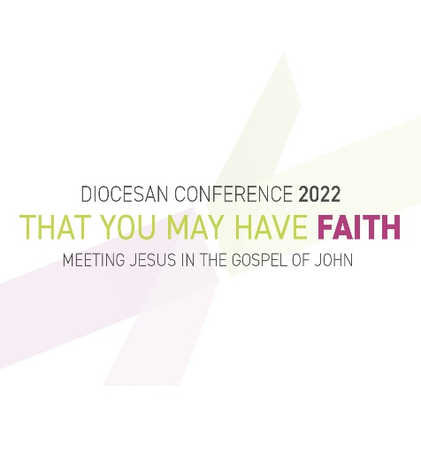
‘That you may have FAITH: Meeting Jesus in the Gospel of John’ is the title of the 4-day Diocesan Conference taking place next week (Mon 7th – Thurs 10th Nov).
You can follow the keynote addresses and other parts of the conference via livestreams on the Diocesan YouTube channel.
There will also be ongoing coverage on the Diocesan Twitter feed @cofelancs and on the Diocesan Facebook page using #havefaith22.
The speaker biographies and other conference details (including the full conference programme day-by-day) are being added to the main conference 'landing page' on the Diocesan website
.Psalms for each day of the week 7th – 12th November:
Mon: Psalm 20 Tues: Psalm 21 Wed: Psalm 23
Thurs: Psalm 26 Fri: Psalm 32 Sat: Psalm 33

The services for the coming weeks given opposite.
Key: DOB: Revd Dave O’Brien; SH: Revd Steve Haskett; DW: Revd David Wilkinson; VB: Vicky Bentley (LLM); YB: Yvonne Blazey (LLM)
Holy Communion Service of the Word

Prayers for healing
during the service
SUNDAY | 10.30am | 6pm
6th Nov.  3rd Sunday before Advent | Luke 20: 27 - 38  Preach:  Archdeacon David  Lead: DOB | 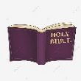  Intercessory Prayer  Isaiah 6: 1 – 8 The King enthroned  Preach: DW  Lead: DOB
13th Nov.  2nd Sunday before Advent | Luke 21: 5 - 19  REMEMBRANCE SUNDAY  Preach: DOB  Lead: DOB | Worship and Bible Teaching  Daniel 7: 1 – 14 The Conquering King  Preach: DOB  Lead: SH
20th Nov.  CHRIST THE KING  Sunday before Advent | Luke 19:  1 – 10  Preach: DW  Lead: DOB | 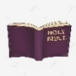  Intercessory Prayer for Healing  Luke 23: 22 – 43 The Crucified King  Preach: DOB  Lead: VB

Midweek (Wed.) Book of Common Prayer Holy Communion Service:
9th Nov. | Luke 20: 27 - 38 Lead/Celebrant/Preach: TBA
16th Nov. | Luke 21: 5 – 19 Lead/Celebrant: DOB Preach: YB
23rd Nov. | Luke 23: 33 – 43 Lead/Celebrant: DW Preach: VB
30th Nov. St Andrew | Matthew 24: 36 – 44 Lead/Preach/Celebrant: DOB

