

***Lord God, whose Son, Jesus Christ,***  
**understood people's fear and pain before they spoke of them,**we pray for those in hospital and at home;  
surround the frightened with Your tenderness;  
give strength to those in pain;  
hold the weak in Your arms of love, and give hope and patience  
to those who are recovering;

we ask this through the same Jesus Christ, our Lord. Amen.

***Lord, hear me as I pray;***

For Sue, Sarah, Sheila, Jack, Leah, Marion, Louise, Debbie, Stephen, Ann, Mary & Keith, Irene, Nic & Joanne, Norman & Jean, Anne & Ian.

For all those we know personally who are ill or struggling at this time in body, mind or spirit.

For all who have recently been bereaved. For Susan in her grief and sadness at this time on the loss of her mother, Edna. *That they may be given comfort and strength in their grief and loss in the knowledge of your Victory over death on the Cross which we focus on in our prayers this Holy Week.*

For all our family and friends.

***Prayer Letter***

***Palm Sunday***

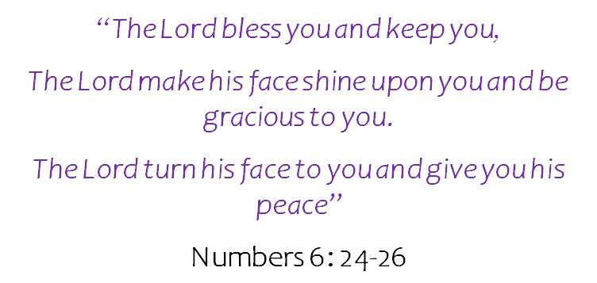

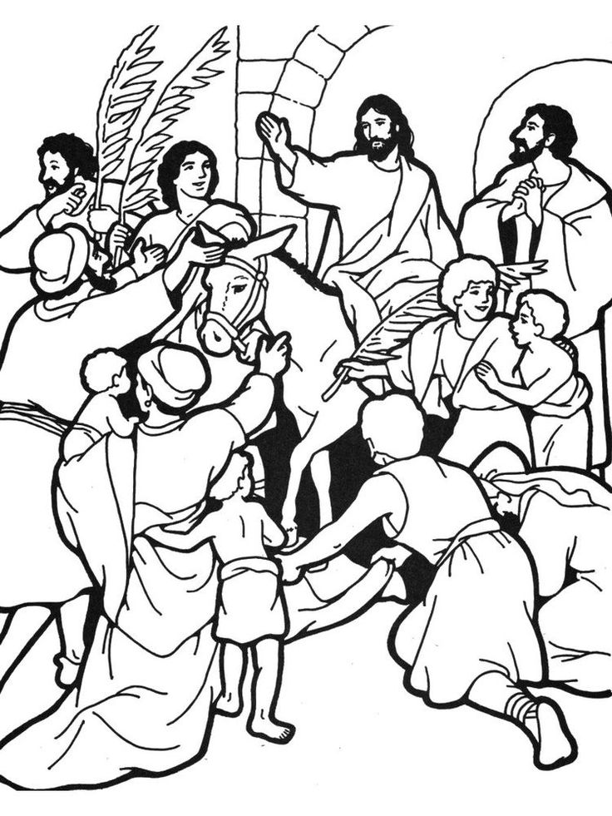

*True and humble king, hailed by the crowd as Messiah:*

*grant us the faith to know you and love you,*

*that we may be found beside you on the way of the cross, which is the path of glory.*

**Amen**

*Our Prayer Letter includes prayers from the Church of England Common Worship and website.*

**Eternal God,**

the light of the minds that know you, the life of the souls that love you,

the strength of the wills that serve you,

help us to so know you that we may truly love you, so to love you that we may truly serve you, whom to serve is perfect freedom.

Lord, pour out Your Holy Spirit upon us and may Your light so shine through us that together we share Your love with everyone and by Your power turn the tide of evil that surrounds us, through Jesus Christ our Lord. Amen.

8thth April 2022

***.”***

***FOR THE CHURCH AND OUR WITNESS TO THE GOSPEL***

**Lord, we pray :**

For our Bishops Julian, Philip and Jill; giving thanks especially for Bishop Julian as he has announced he will be retiring in the summer.

For our Vicar Dave, for Alison and Josh.

For our Curate Emma in her continuing ministry with our Church and as she prepares for her new position in the parish of Lytham, to work as a mission enabler this Summer.

For Revd Steve and Lisa, for the work of Life Association in India, for all our brothers and sisters there, for the work of mission and care.

For Matt and everyone involved in the work with children and young people.

For all who attend our church, that they are safe and renewed in the knowledge and belief in your promise that you are the God of love and forgiveness by your sacrifice for our sins on the Cross of Salvation.

***"I write these things to you who believe in the name of the Son of God so that you may know that you have eternal life."***

1 John 5:13

***Lord, hear me as I pray;***

For our community, for all the people who live and work around us.

For Devonshire Primary Academy: teachers, other staff, children, parents, grandparents and carers.

For all in our community whose lives are impacted by mental health difficulties, chronic pain, illness or disability.

For all in need of help with any personal, financial or social issues they are struggling to cope with at this difficult time for so many – That they may access the help and support they need to overcome their difficulties.

***Let us pray for the church, the world and ourselves and let us thank God for His goodness:***

Lord God, we ask that you protect all who work for peace in our troubled world. We pray for all those whose lives have been affected by war and the consequences of war, especially at this time in:

**Yemen**, where war has been ongoing for many years.

**Afghanistan**, where there is suffering from malnutrition.

**Ukraine,**  for the people of Bucha and other towns, villages & cities devastated by the invading forces. We also pray for all under who are threatened by heavy military offensives and sustained land and sea blockades by Russian military forces.

We pray that there will soon be and end to the war and that the people of Ukraine and Russia will one day be able to live in peace - Free from the tyranny which has brought about this tragedy for both nations, and which threatens the peace and security of the world which you gave to us to be stewards of.

.

***Lord, hear me as I pray;***

Give wisdom to all in authority especially Elizabeth, our Queen. We thank You Lord God for her life of service and her faith in Jesus Christ.

For all those is position of power across all Governments – national, regional and local – give them wisdom in their decision-making and strength of purpose for our common good.

Pray for people everywhere who feel helpless and afraid as they witness day by day the devastation & evil being done against the Ukrainian people.

**Eternal God,**

In whose perfect realm

no sword is drawn but the sword of righteousness, and

no strength known but the strength of love:

so guide and inspire the work of those who seek your kingdom

that all your people may find their security in that love which casts out fear

and in the fellowship revealed to us in Jesus Christ our Saviour. Amen,