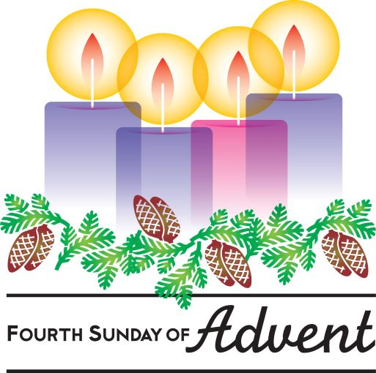

***“Love that passes all understanding***

***is found in Christ”***

**Ephesians 3: 19**

***L O V E***

***Lord, hear me as I pray;***

For HM the Queen, leaders in our Churches and in the Judiciary

For our political leaders in national, devolved and local Government, the Mayor of our Capital and also the Mayors of our Metropolitan regions

For those who serve in our armed forces in the UK and those on active service overseas

For all whose lives have been devastated by the house fire tragedies in Reading and in London in the past week. Also for the Police, Ambulance and Fire and Rescue staff who were involved at the incidents and in the ongoing investigations

For your protection upon the people of our nation from the impact of the new omicron strain of covid 19 and other winter respiratory infections and for us all to do what we can to protect each other

For our teachers as they work with children in schools where the new variant is believed to be a significant reservoir for transmission

For our scientists who are working to understand more about emerging strains of Covid 19 and methods to protect us from the worst effects.

For those working extra hours and through the night as their workload increases in the coming week

For all who give their time to volunteer in food banks and soup kitchens around our nation

***Prayer Letter***

***Lord, hear me as I pray;***

For our Vicar Dave and our Curate Emma

For Steve and Lisa for their overseas ministry in India and their work in our Parish

For our Church Warden, Pauline and all who help in welcoming people to our Church

For Matthew and Rosie in their work with the children, youth and families of our Parish

For our licenced lay ministers and all who are authorised lay ministers in our Parish

For all who give their time in whatever way they can, to assist the mission of our church, in service to God and in helping others – For Alison in her work with Ashar

That all who visit our Church will come to know your amazing love, compassion and forgiveness for them, in whatever personal situations they may have experienced or be experiencing as they come into your presence.

*“Now my eyes will be open and my ears attentive to the prayers offered in this place”.*

***2 Chronicles 7:15***

19th December 2021

***.”***

***Lord, hear me as I pray;***

For your protection for all who are fleeing countries around our world as refugees from war and persecution

For the many Christian charities and Christian NGOs working to bring hope for all who are suffering as the result of war, natural and man-made disaster

For the work of the Disasters Emergency Committee as it seeks to raise funds and deliver urgent medical and other humanitarian assistance to help the people of Afghanistan.

[**www.dec.org.uk/appeal/afghanistan-crisis-appeal**](http://www.dec.org.uk/appeal/afghanistan-crisis-appeal)

***Lord, hear me as I pray;***

For elected representatives in Parliament and on Blackpool Borough Council

For the community of Devonshire Primary Academy: teachers, other staff, children, parents, grandparents and carers

For all who live or work in Caledonian Avenue, Cumbrian Avenue and Campbell Avenue

For all who are struggling with their physical or mental health, those who are lonely and those suffering hardship and those who feel helpless and struggling to cope with caring for a loved one and for those who isolating because of the impact of Covid 19

***“For to us a child is born, to us a son is given; and the government shall be upon his shoulder,***

***And his name shall be called Wonderful Counsellor, Mighty God, Everlasting Father, Prince of Peace”. Isaiah 9:6***

***Lord, hear me as I pray;***

For Christians facing persecution in parts of our world where there is for them the constant risk of imprisonment, torture and death

For those who have been left homeless, injured or bereaved following the powerful tornadoes which crossed six States of the United States

For those who have been affected by the volcanic eruptions on the island of Java and the fire disaster in Osaka, Japan.

For reconciliation and peace between the different peoples of our troubled world and for de-escalation of the situation caused by the rapid military build of Russian forces on its border with Ukraine

***Lord, hear me as I pray;***

For our family members, our friends and colleagues in our places of work

ForSheila, Jack, Leah, Louise, Debbie, Nic and Joanne, Bob and Sue, Norman and Jean, Anne and Wendy

We also remember and pray for all those we know personally who are ill or struggling at this time in body, mind or spirit.

For all who will be missing family members this Christmas, including those serving overseas and separated from their loved ones.

For all who have been recently bereaved -That they may be given comfort and strength in their grief and loss.