Lord, hear me as I pray;
Prayer Letter
2nd Sunday after Trinity
26th June 2022

For all who are increasingly affected by the surges in the cost of every
day essentials such as food, mortgages fuel, gas and electricity.

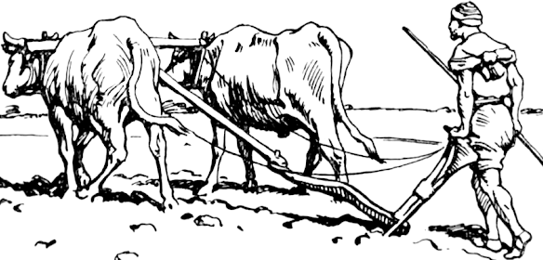
"Any who put their hand to the plough and then look back, are unfit for service in the Kingdom of God"
Luke 9: 62
"The Lord bless you and keep you.
The Lord make His face shine upon you and be gracious to you.
The Lord turn His face to you and give you His peace."

Numbers 6: 24-26
- Lord of comfort and peace, we ask that you be with all those who suffer pain and anguish in bereavement; and for all who are struggling with infirmity or pain in body, mind or spirit.

For those in hospital and at home;
surround the frightened with Your tenderness;
give strength to those in pain;
hold the weak in Your arms of love, and give hope and patience
to those who are recovering.

We bring before you now in Your healing power:
Sue, Sarah, Leah, Gordon, Louise, Debbie, Stephen, Norman and Jean, Anne and Ian.

Thank you, Jesus. Amen

Lord, hear me as I pray;

For the Archbishops of Canterbury and York, and for all other Christian leaders across our nation.

For our Vicar Dave, for Alison and Josh. Also for the work of Ashar and those attending Starting Point.

For Steve and Lisa in their mission with the poor in India and in our Parish and for Emma, giving thanks for her service in our parish as she prepares to continue her Curacy in Lytham.

For Matt and everyone involved in the work with children and young people.

For all who attend our church. That all are safe and renewed in the knowledge and belief in your promise that you are the God of love and forgiveness.

For every one at St Thomas' helping to build Your Kingdom in our
Parish, our town and also the wider world.

Lord God, we ask that you protect all who work for peace in our troubled world. We pray for all those whose lives and nations are affected by war and the consequences of war as we continue to pray especially for:

Afghanistan, we pray for all who have been affected by the earthquake , especially those who have been bereaved and those who have been injured and those made homeless. We also pray for the rescue efforts taking place and that International rescue services with soon be able to assist in the aftermath.

Ukraine, we pray that there will be a lasting and just peace to end the suffering and death caused by the.

Refugees and asylum seekers, we continue to pray that there are fair and just solutions to the current issues relating to the Government's Rwandan deportation scheme.

For our planet, we pray that their will be increased drive to move to solutions to reduce the impact of human induced global warming which threatens the future of many nations and people around our world.

For the people of Somalia, and other nations in Africa and Asia facing severe drought and famine.

For the people of Bangladesh and India who have been bereaved or made homeless by the recent severe floods.

.”
Lord, hear me as I pray;
Give wisdom to all in authority especially Elizabeth, our Queen. We thank You Lord God for her long life of service and her faith in Jesus Christ which is an inspiration to us all.

For our Armed Forces, protecting us in our nation by their service at sea, in the air and on land. Especially for those on deployment along NATOs eastern European borders and in operations to assist Ukraine in the face of Russia's onslaught.

For all those is position of power across all Governments in the UK – national, regional and local – We also pray for the two new members of the house of Commons on their election to serve as MPs; Simon lightwood in Wakefield and Richard Foord in Tiverton and Devon.
Lord, hear me as I pray;

For the emergency services across our town and around our nation

For the teachers, other staff and pupils in the schools and colleges across our town and around our

For our Social workers, Health Care workers and volunteers providing care and support to the vulnerable, the hungry, and the sick across our town and around our nation.

For our airport workers and all those affected by the difficulties of staffing, particularly with adequately staffed security areas.

