

***Lord God, whose Son, Jesus Christ,***  
**understood people's fear and pain before they spoke of them,**we pray for those in hospital and at home;  
surround the frightened with Your tenderness;  
give strength to those in pain;  
hold the weak in Your arms of love, and give hope and patience  
to those who are recovering;

we ask this through the same Jesus Christ, our Lord. Amen.

***Lord, hear me as I pray;***

For Sue, Sarah, Sheila, Jack, Leah, Marion, Louise, Debbie, Stephen, Ann, Mary & Keith, Irene, Nic & Joanne, Norman & Jean, Anne & Ian.

For all those we know personally who are ill or struggling at this time in body, mind or spirit.

For all who have recently been bereaved. That they may be given comfort and strength in their grief and loss. For Susan in her grief and sadness at this time on the loss of her mother, Edna.

For all our family and friends.

***Prayer Letter***

***The Fifth Sunday in Lent***

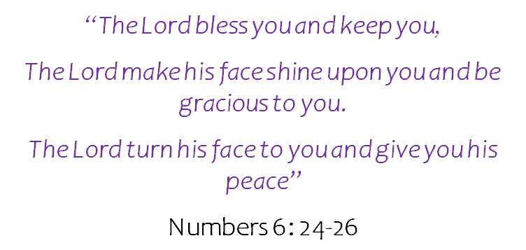

*Our Prayer Letter includes prayers from the Church of England Common Worship and website.*

***The Lord’s Prayer (New Zealand, Polynesia and Aotearoa)***

Eternal Spirit

Earth-maker, Pain-bearer, Life-giver,

Source of all that is and that shall be,

Father and mother of us all.

Loving God, in whom is heaven:

The hallowing of Your name echo through the universe!

The way of Your justice be followed by the peoples of the world!

Your heavenly will be done by all created beings!

Your commonwealth of peace and freedom sustain our hope and come on earth.

With the bread we need for today, feed us.

In the hurts we absorb from one another, forgive us.

In times of temptation and test, strengthen us.

From the grip of all that is evil, free us.

For You reign in the glory of the power that is love,

Now and for ever. Amen.

**Eternal God,**

the light of the minds that know you, the life of the souls that love you,

the strength of the wills that serve you,

help us to so know you that we may truly love you, so to love you that we may truly serve you, whom to serve is perfect freedom.

Lord, pour out Your Holy Spirit upon us and may Your light so shine through us that together we share Your love with everyone and by Your power turn the tide of evil that surrounds us, through Jesus Christ our Lord. Amen.

3rd April 2022

***.”***

***Let us pray for the church, the world and ourselves and let us thank God for His goodness:***

Lord God, we ask that you protect all who work for peace in our troubled world. We pray for all those whose lives have been affected by war and the consequences of war. We also pray for those who are living in worry of the weapons of modern war being used indiscriminately and inhumanely. We pray for all in our world at risk of harm through the cruel aggression of the more powerful, and for a softening of the hearts of the oppressors to allow peace, reconciliation and reconstruction to replace war.

For integrity, justice and peace throughout the world, especially in:

**Yemen**, where war has been ongoing for many years.

**Afghanistan**, where there is suffering from malnutrition.

**Ukraine** and all its people - For the survivors in the devastated city of Mariupol and in other towns, cities and villages across that nation who are under attack, denied access to water, shelter, heating, food and medical assistance by the Russian army and naval blockades and bombardment of their beautiful and peaceful lands.

Grant, Lord God, peace in Your world in our time.

Through Jesus Christ our Lord. Amen.

***FOR THE CHURCH AND OUR WITNESS TO THE GOSPEL***

**Lord, we pray :**

For our Bishops Julian, Philip and Jill; giving thanks especially for Bishop Julian as he has announced he will be retiring in the summer.

For our Vicar Dave, for Alison and Josh.

For our Curate Emma in her continuing ministry with our Church and as she prepares for her new position in the parish of Lytham, to work as a mission enabler this Summer.

For Revd Steve and Lisa, for the work of Life Association in India, for all our brothers and sisters there, for the work of mission and care.

For Matt and everyone involved in the work with children and young people.

For all who attend our church, that they are safe and renewed and know that you are the God of love, mercy, grace and forgiveness. For Theo, on his Baptism at St Thomas' and for his family and all those who will love and support him in his walk with you throughout his life.

For all who serve on our PCC, all those who are serving you in our Parish in so many different ways and for those being called to serve. Also for all who are working to find solutions to the building use and safety issues of our Parish Centre.

***Lord, hear me as I pray;***

For our community, for all the people who live and work around us.

For Devonshire Primary Academy: teachers, other staff, children, parents, grandparents and carers.

For all in our community whose lives are impacted by mental health difficulties, chronic pain, illness or disability.

For all in need of help with any personal, financial or social issues they are struggling to cope with at this difficult time for so many – That they may access the help and support they need to overcome their difficulties.

**Eternal God,**

In whose perfect realm

no sword is drawn but the sword of righteousness, and

no strength known but the strength of love:

so guide and inspire the work of those who seek your kingdom

that all your people may find their security in that love which casts out fear

and in the fellowship revealed to us in Jesus Christ our Saviour. Amen,

***Lord, hear me as I pray;***

Give wisdom to all in authority especially Elizabeth, our Queen. We thank You Lord God for her life of service and her faith in Jesus Christ.

For all those is position of power across all Governments – national, regional and local – give them wisdom in their decision-making and strength of purpose for our common good.