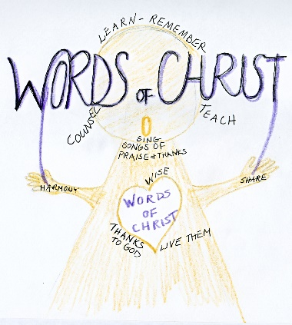
the picture entitled ‘Pay Attention’ is from ‘Writing Vision’ by Kathleen S Evenhouse and reflects a verse from our reading from Colossians this Sunday morning – Colossians 3 v 16.

Lent - a time of personal reflection before God, saying sorry – a time of being renewed spiritually, a time of deep prayer. We are told many times in the Gospels that Jesus withdrew to be alone with God the Father and to pray. May we take this time to draw our strength from God in prayer, let the words of Christ be refreshed in us and keep on directing others to Jesus.

24 hour Prayer event 31st March 7pm until 8pm 1st April 2023 in person St Thomas Church Blackpool or from home.
If you can come and pray in church, please do put your name down on the sign up sheet in the church lounge to say the time you will be there.
See Denise for more information.

Other events coming up:
APRIL – 7th April GOOD FRIDAY 9th April EASTER DAY
29th April Street visits, BBQ and Fun Day
Sunday 30th April George and Joan Fisher at 10.30am and 6pm services

Psalms for each day of the week 6th March – 11th March:
Mon: Psalm 32 Tues: Psalm 106 Wed: Psalm 35
Thurs: Psalm 34 Fri: Psalm 41 Sat: Psalm 25

The services for the coming weeks are given on the opposite page.
Key: DOB: Revd Dave O’Brien; DW: Revd David Wilkinson;
YB: Yvonne Blazey; CB: Chris Blazey; VB: Vicky Bentley; IL: Irene Leak
Holy Communion Service of the Word
SUNDAY | 10.30am | 6pm
5th March  Lent 2 | Theme:  Colossians 3:  1 – 17  John 3: 1 – 17  Lead: DOB  Preach: CB | Theme:  Matthew 9: 35 – 38  Jesus: God of Compassion  Lead: DOB  Preach: VB
12th March  Lent 3 | Theme:  Colossians 3:  18 – 25; 4: 1  John 4: 5 – 42  Lead: DOB  Preach: DOB | Theme:  John 1: 29 – 34  Jesus: God of Holiness  Lead: DW  Preach: DOB
19th March  Lent 4  MOTHERING SUNDAY | Theme:  1 Samuel 16:  1 – 13  John 19: 17 – 27  Lead: DOB  Preach: YB | Theme:  Luke 13: 31 – 35  Jesus: Care of a Mother  Lead: DOB  Preach: IL
26th March  Lent 5 | Theme: Colossians 4:  2 – 18  John 12: 20 – 33  Lead: DOB  Preach: VB | SERVICE OF THE WORD AND HEALING SERVICE  Romans: 10: 1 – 15  Proclamation  Lead: VB  Preach DOB

Midweek Book of Common Prayer Holy Communion Service at 11am:
8th March Matthew 20: 17 – 28  Lead/Preach: DOB | 15th March Matthew 5: 17 – 19  Lead: DOB Preach: YB
22nd March John 5: 17 – 30  Lead: DOB Preach: VB | 29th March John 8: 31 – 42  Lead/Preach: DOB

