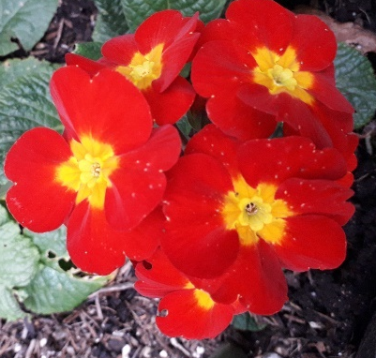
Taken from the Gospel reading (John 7) set for Monday evening :
“On the last and greatest day of the festival, Jesus stood and said in a loud voice, ‘Let anyone who is thirsty come to me and drink. Whoever believes in me, as scripture has said, rivers of living water will flow from within them.’ By this he meant the Spirit, whom those who believed in him were later to receive…………Finally the temple guards went back to the chief priests and the Pharisees, who asked them, ‘Why didn’t you bring him in?’
‘No one ever spoke the way this man does’, the guards replied.”

Service schedule for the coming weeks:
Sunday  20th March  LENT 3 | 10.30am MISSION WEEK Service of the Word  Special guest: Pete Tomkinson – come and hear about being God’s Soldier  6pm Prayer Gathering/ Breaking of Bread
Wednesday 23rd March | 11am BCP Holy Communion  Reading: Luke 11: 14 - 28  Leader: DOB Celebrant: DOB Preacher: VB
Sunday  27th March  LENT 4 | 10.30am Holy Communion with Prayer for Healing  Reading: Luke 5: 12 - 16  Leader/Celebrant: ES Preacher: VB  Theme: Jesus cares  6pm Prayer Gathering/Prayer for Healing DOB/YB
Wednesday 30th March | 11am BCP Holy Communion  Reading: John 6: 1 - 14  Leader: DOB Celebrant: DOB Preacher: DOB
Sunday  3rd April  LENT 5 | 10.30am Service of the Word  Reading: John 12: 1 – 8  Leader: DOB Preacher: ES  Theme: Jesus anointed at Bethany  6pm Prayer Gathering/Breaking of Bread DOB/VB
Wednesday  6th April | 11am BCP Holy Communion Reading: John 8: 46 - 59  Leader: ES Celebrant: ES Preacher: DOB
Sunday  10th April  PALM SUNDAY | 10.30am Holy Communion  Reading: Matthew 21: 1 - 13  Leader/Celebrant: ES Preacher: DOB  Theme: Hosanna to Jesus the King  6pm Prayer Gathering/Prayer for Healing ES/CB
 | Midweek services begin again on Wednesday 27th April

Our morning and evening readings for the coming week:
 | Morning Readings | Evening Readings
Monday 21st March  Thomas Cranmer, archbishop, Reformation martyr 1556 | Psalm 7;  Genesis 47: 1 – 27;  Hebrews 4: 14 – 5: 10 | Psalm 17;  Jeremiah 11: 1 – 17;  John 7: 37 - 52
Tuesday 22nd March | Psalm 9;  Genesis 47: 28 – end of 48;  Hebrews 5: 11 – 6: 12 | Psalm 64;  Jeremiah 11: 18 – 12: 6;  John 7: 53 – 8: 11
Wednesday 23rd March | Psalm 38;  Genesis 49: 1 – 32;  Hebrews 6: 13 – end | Psalm 39;  Jeremiah 13: 1 – 11;  John 8: 12 - 30
Thursday 24th March  Walter Hilton, mystic 1396; Paul Couturier, priest, ecumenist, 1953; Oscar Romero, archbishop, martyr, 1980 | Psalm 56;  Genesis 49: 33 – end of 50;  Hebrews7: 1 – 10 | Psalm 85;  Genesis 3: 8 – 15;  Galatians 4: 1 - 5
Friday 25th March  Annunciation of Our Lord to the Blessed Virgin Mary | Psalms 111, 113;  1 Samuel 2: 1 – 10;  Romans 5: 12 – end | Psalms 131, 146;  Isaiah 52: 1 – 12;  Hebrews 2: 5 - end
Saturday 26th March  Harriet Mansell, founder of the Community of St John the Baptist, 1883 | Psalm 31;  Exodus 1: 22 – 2: 10;  Hebrews 8 | Psalm 116;  Jeremiah 16: 10 – 17: 4;  John 9: 1 - 17
(the LORD said…) Now my eyes will be open and my ears attentive to the prayers offered in this place. (2 Chron, 7: 15)

