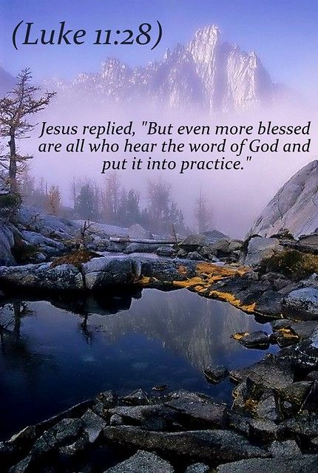
On Tuesday this week in the Church’s calendar we remember Luke the Evangelist, writer of the Gospel that bears his name as well as the Book of Acts. One of the readings set for Tuesday is 2 Timothy 4 which includes “ …keep your head in all situations, endure hardship, do the work of an evangelist, discharge all the duties of your ministry.” Also known as a physician, in thinking of Luke let’s remember and pray for all those who provide medical care, all those who work in our hospitals and at Trinity Hospice, all those who provide emotional and mental care and support. We at St Thomas’ this week give thanks for the life and faithful service of Sue Waite. Her funeral takes place on Friday (21st) at 11am in church. It seems fitting to include this extract also from 2 Tim. 4: “I have fought the good fight, I have finished the race, I have kept the faith. Now there is in store for me the crown of righteousness, which the Lord, the righteous judge, will award to me on that day – and not only to me, but also to all who have longed for his appearing.”
Collect for St Luke’s day:
Almighty God, You called Luke the physician whose praise is in the gospel, to be an evangelist and physician of the soul: by the grace of the Spirit and through the wholesome medicine of the gospel, give your Church the same love and power to heal; through Jesus Christ your Son our Lord, who is alive and reigns with you, in the unity of the Holy Spirit, one God, now and for ever. Amen.
PRAISE AND WORSHIP EVENING Friday 28th October 2022 in church starting at 7pm. A time for us as a whole church to come together to enjoy extended worship and prayer, giving thankful praise to our God and seeking His Holy Spirit for refreshing and direction.
Psalms for each day of the week 17th – 22nd October:
Mon: Psalm 80 Tues: Psalms 145, 146 Wed: Psalm 119 v 105 - 128
Thurs: Psalm 92 Fri: Psalm 88 Sat: Psalm 97
The services for the coming weeks given opposite.
Key: DOB: Revd Dave O’Brien; SH: Revd Steve Haskett;
VB: Vicky Bentley
Holy Communion Service of the Word

Prayers for healing Children’s Bible Study
during the service & Family Worship
SUNDAY | 10.30am | 3 – 4pm and  4 - 5pm | 6pm
16th Oct.  Trinity 18 | Luke 18: 1 – 8  Preach: SH  Lead: DOB |  | 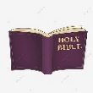  Healing Service  Romans 10: 1 – 15  Proclamation  Preach: DOB  Lead: SH
23rd Oct.  Last Sunday after Trinity | Luke 18:  9 – 14  Preach: DOB  Lead: DOB |  | Worship and Bible Teaching  Matthew 7: 7 - 12  Prayer  Preach: DOB  Lead: VB
30th Oct.  ALL SAINTS | Luke 19:  1 – 10  Preach: VB  Lead: DOB |  | 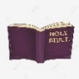  Revelation 7: 9 – 17  Memorial/  Invitation Service  Remembering those we love  Lead: VB  Preach: DOB
Midweek (Wed.) Book of Common Prayer Holy Communion Service:
19th Oct. | Luke 18: 1 – 8 Lead/Celebrant/Preach: DOB
26th Oct. | Luke 18: 9 – 14 Lead/Celebrant: DOB Preach: VB

