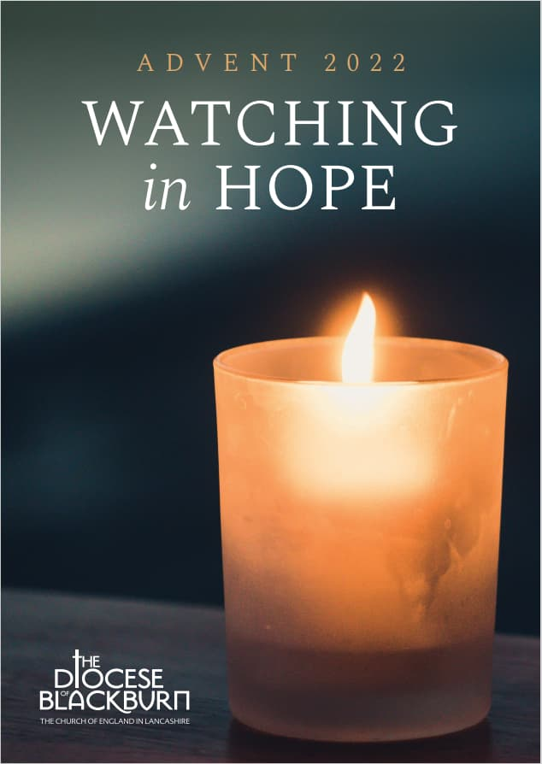
The ADVENT season begins next Sunday 27th November and our Diocese has provided this study booklet through every church and online through the Diocesan website.
It is hoped that our small groups will use the study guide when they meet during this season, to watch in hope and to think about the significance of the first coming of Christ, which we will celebrate at Christmastide.

There is a host of resources available to help you in daily Bible reading and prayer:
Daily Prayer on the Church of England website; Lectio 365, BIOY (www.bibleinone year.org); The Vine – please have a chat with Denise (Moorby) about this simple and flexible framework for living out the Christian life.

At the time of writing, we have initial arrangements for the funeral of
Jack Hull, the date is Monday 12th December, 11.00am in church followed by a service of committal at Carleton at 12.30pm.

Psalms for each day of the week 21st – 26th November:
Mon: Psalm 96 Tues: Psalm 97 Wed: Psalm 112
Thurs: Psalm 125 Fri: Psalm 139 Sat: Psalm 145

The services for the coming weeks are given opposite.
Key: DOB: Revd Dave O’Brien; SH: Revd Steve Haskett; DW: Revd David Wilkinson; VB: Vicky Bentley (LLM); YB: Yvonne Blazey (LLM);
CB: Chris Blazey; IL: Irene Leak
Holy Communion Service of the Word

Prayers for healing
during the service
SUNDAY | 10.30am | 6pm
20th Nov.  CHRIST THE KING  Sunday before Advent | Luke 19:  1 – 10  Preach: SH  Lead: DOB  Life Association presentation | 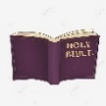  Intercessory Prayer for Healing  Luke 23: 22 – 43 The Crucified King  Lead/Preach: DOB
27th Nov.  ADVENT 1 | Matthew 24:  36 – 44  Preach: DOB  Lead: YB | Worship and Bible Teaching  Matthew 24:  36 – 44  The Coming King  Preach: VB  Lead: DOB
4th Dec.  ADVENT 2 | Matthew 3: 1 -12  Preach: VB  Lead: DOB | 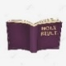  Prayer and Worship Gathering  Intercessory Prayer  Luke 1: 46 – 55  The Humble King  Preach: CB  Lead: DOB
11th Dec.  ADVENT 3 | Matthew 11: 2 – 11  Preach: DW  Lead: DOB | Worship and Bible Teaching  John 18: 28 – 40  The Servant King  Preach: IL  Lead: SH
Midweek (Wed.) Book of Common Prayer Holy Communion Service:
23rd Nov. | Luke 23: 33 – 43 Lead/Celebrant: DW Preach: VB
30th Nov. St Andrew | Matthew 24: 36 – 44 Lead/Preach/Celebrant: DOB
7th Dec. | Matthew 3: 1 – 12 Lead/Celebrant: DOB Preach: YB
14th Dec. | Matthew 11: 2 – 11 Lead/Preach/Celebrant: DOB
Following this service on 14th Dec, Midweek Communion will recommence in the New Year.

