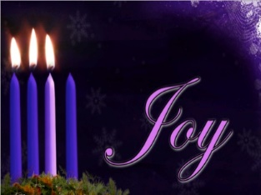
In Western Christianity, the third Sunday of Advent is also known as Gaudete Sunday. Gaudete is Latin for “Rejoice”. An anthem that is sometimes sung in churches is based on: "Rejoice in the Lord always; again I say, rejoice. Let your forbearance be known to all, for the Lord is near at hand; have no anxiety about anything, but in all things, by prayer and supplication, with thanksgiving, let your requests be known to God.." Philippians 4:4–6
2023 STEWARDSHIP ENVELOPES – available today in the church lounge. If anyone would like to give regularly to the work of God at St Thomas, please have a chat to Vicky (Bentley).
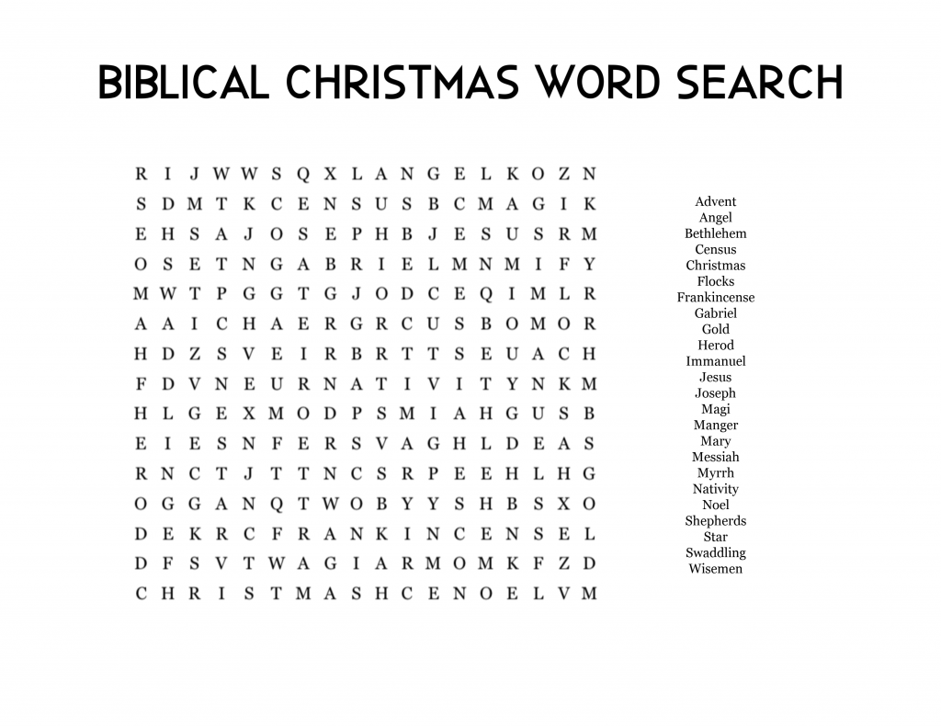
at 12.30pm.
Psalms for each day of the week 12th – 17th December:
Mon: Psalm 40 Tues: Psalm 70 Wed: Psalm 75
Thurs: Psalm 76 Fri: Psalm 98 Sat: Psalm 71
The services for the coming weeks are given below
Key: DOB: Revd Dave O’Brien; DW: Revd David Wilkinson

Midweek (Wed.) Book of Common Prayer Holy Communion Service:
14th Dec. | Matthew 11: 2 – 11 Lead/Preach/Celebrant: DOB
Christmas break – this service will then recommence 4th January 2023
SUNDAY | 10.30am | Evening
11th Dec.  ADVENT 3 | Theme:  Matthew 11:  2 – 11  Preach: DW  Lead: DOB | SPECIAL GATHERING 5pm  DEVONSHIRE ACADEMY CHOIR and  LIGHTING OUR CHRISTMAS TREE
18th Dec  ADVENT 4 | Theme:  Matthew 1:  18 –25  Preach:  Archdeacon Mark Ireland  Lead: DOB | 6pm Service of the Word  7 Lessons and Carols  Gospel Presentation  Theme: John 1: 1 – 14  The Word made flesh  Preach:  Archdeacon Mark Ireland  Lead: DOB
SATURDAY  24th Dec  CHRISTMAS  EVE | MIDNIGHT COMMUNION  Theme: Luke 2: 1 – 14  Lead/Preach: DOB
SUNDAY  25th Dec  CHRISTMAS DAY | 10.30AM Service of Holy Communion  Theme: John 1: 1 – 14  Lead/Preach: DOB
1st Jan 2023  CHRISTMAS 2 | 10.30AM Service of Holy Communion  Theme: Luke 2: 15 - 21  Lead/Preach: DOB

