- Lord of comfort and peace, we ask that you be with all those who suffer pain and anguish in bereavement; and for all who are struggling with infirmity or pain in body, mind or spirit.
For those in hospital and at home;
surround the frightened with Your tenderness;
give strength to those in pain;
hold the weak in Your arms of love, and give hope and patience
to those who are recovering.
We bring before you now in Your healing power:
Sue, Sarah, Leah, Louise, Debbie, Stephen, Norman and Jean, Anne and Ian.
Thank you, Jesus. Amen

Prayer Letter
6th Sunday of Easter

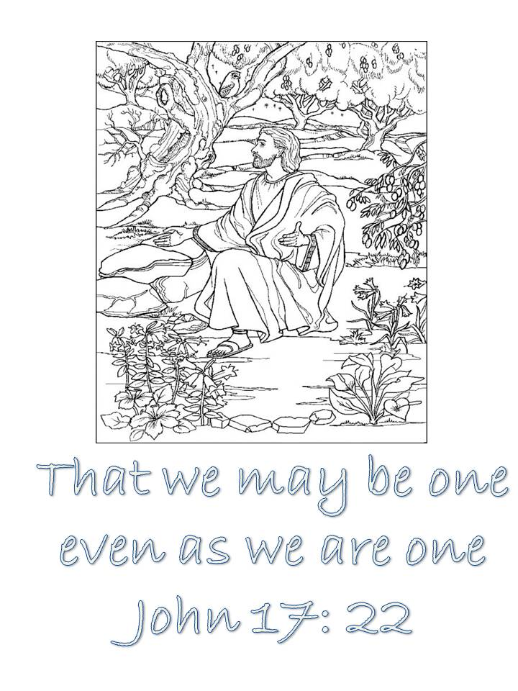
Blesed are those who have not seen yet have believed
Let hear me as I pray :

For our world, and all You have provided to us. That we may be
Stewards for its protection and for future generations who will follow us.

For all Christians who work in the fields of science and medicine. That their witness and faith in You inspires young people wishing to pursue a vocation in science or medicine to see and understand that You are the God of creation and wonder and that nothing is impossible for You.
29th May 2022
We give thanks to You, Father God, for life of our friend and brother Nic Hall and we pray, O Lord, please comfort all those who grieve and especially Joanne and all their family and friends.
Lord, pour out Your Holy Spirit upon us and may Your light so shine through us, that together we share Your love with everyone and by Your power turn the tide of evil that surrounds us,
through Jesus Christ our Lord. Amen
"The Lord bless you and keep you.
The Lord make His face shine upon you and be gracious to you.
The Lord turn His face to you and give you His peace."

Numbers 6: 24-26

Let us pray for the church, the world and ourselves and let us thank God for His goodness:

Lord God, we ask that you protect all who work for peace in our troubled world. We pray for all those whose lives and nations are affected by war and the consequences of war as we continue to pray especially for:

Yemen, where war has been ongoing for many years and where powerful modern weapons have led to many casualties and deaths of civilians, including children.

Afghanistan, where there is suffering from malnutrition and constant fear from terrorist groups carrying out indiscriminate attacks across that nation.

Ukraine, that there will soon be and end to the indiscriminate horrific war waged by Russia - At this time for all those under constant bombardment and those fighting valiantly to resist the invading forces of Russia.

For an end to the world food shortages caused by the Russian Naval Blockade and military action against Ukrainian port Cities, including Odessa which is threatening the poorest in our world with imminent starvation

For the City of Uvalde, Texas, and all who have been bereaved or wounded in the massacre at the Robb Elementary Primary school.

Also, that politicians protecting the existing rights of the gun lobby and the NRA in the United States, finally have the courage to change their views and support Constitutional changes to protect the innocent from the dangers of widely and easily available sales of military type automatic firearms and ammunition.

Lord, hear me as I pray :

For the Archbishops of Canterbury and York, and for all other Christian leaders across our nation.

For our Bishops Julian, Philip and Jill; giving thanks especially for Bishop Julian as he approaches his retirement .

For our Vicar Dave, for Alison and Josh. Also for the work of Ashar and those attending Starting Point, brew and a chat and all who take part in emotional, mental and spiritual well-being support.

For our Curate Emma in her continuing ministry with our Church and as she prepares for her new position in the parish of Lytham, to work as a mission enabler this Summer.

For Matt and everyone involved in the work with children and young people.

For all who attend our church that they are safe and renewed in the knowledge and belief in your promise that you are the God of love and forgiveness by your sacrifice for our sins on the Cross of Salvation.

For those who serve on the PCC and in so many other ways with St Thomas' to assist in building Your Kingdom in our Parish , our town and also the wider world.

For the work of Steve and Lisa in their mission with the poor in India and for the work and witness of Life Association. Amen
- Lord, hear me as I pray :
- For the emergency services across our town and around our nation
- For the teachers, other staff and pupils in the schools and colleges across our town and around our nation - Especially those young people preparing for exams at this time.
- For our Social workers, Health Care workers and volunteers providing care and support to the vulnerable, the hungry, and the sick across our town and around our nation.
- For all who live or work in our Parish and for all who visit our town for work or leisure.

.”
Lord, hear me as I pray;
Give wisdom to all in authority especially Elizabeth, our Queen. We thank You Lord God for her long life of service and her faith in Jesus Christ as her Platinum Jubilee Celebrations get under way.

For the ongoing economic problems in our country, where the cost of living continues to rise and people are struggling to make ends meet.

For all those is position of power across all Governments in the UK – national, regional and local – Grant them integrity, compassion and wisdom in their decisions to benefit all they have been elected to serve. Amen

