THE QUEEN’S PLATINUM JUBILEE
– CHURCH PICNIC
After the 10.30am church service this mroning (5th June), we are having a picnic to celebrate Queen Elizabeth II’s 70 years reign – tables and chairs will be outside on the grass, come and enjoy the party.

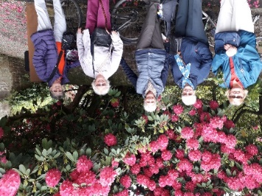
FLOWERS in the Church entrance – is there anyone who would be willing to go on the rota to do the flowers in the church entrance? Please have a talk with Pauline or Marion (Hornby).
LADIES DAY – Saturday 18th June - please see the information and sign up sheets at the back of church.
The photo on the right is of some church friends enjoying the gardens at Bleasdale Tower.
Morning Psalms for each day of the week
6th June – 11th June :
Mon: Psalm 126 Tues: Psalm 132 Wed: Psalm 119 v 153 - end
Thurs: Psalm 143 Fri: Psalm 144 Sat: Psalms 100, 101, 117
The services for the coming weeks given on the opposite page.
Key: CB: Chris Blazey; YB: Yvonne Blazey; SH: Revd Steve Haskett; DOB: Revd Dave O’Brien; ES: Revd Emma Swarbrick
Holy Communion Service of the Word

Prayers for healing Children’s Bible Study
during the service Family
Celebration
Each SUNDAY | 10.30am Intergenerational Service | 3 – 4pm Children’s Bible Study and 4 – 5pm Family Celebration | 6pm Worship, Prayer and Bible Teaching
SUNDAY | 10.30am | 3 - 4 and  4 - 5pm | 6pm
5th June  PENTECOST | Acts 2:  1 – 21  Preach: SH  Lead: ES |  | Acts 2:  1 – 21  Preach: DOB  Lead: SH
12th June  TRINITY SUNDAY | John 16: 12 – 15  Preach: DOB  Lead: ES |  | John 16: 12 – 15  Preach: YB  Lead: DOB
19th June  Trinity 1 | Luke 8: 26 – 39  Preach: ES  Lead: DOB |  | Luke 8: 26 – 39  Preach: CB  Lead: DOB
26th June  Trinity 2  Prayer for healing during the services | Luke 9:  51 – end  Preach: SH  Lead: DOB |  | Luke 9:  51 – end  Preach: CB  Lead: ES

Midweek (Wed.) Book of Common Prayer Holy Communion Service:
8th June | John 14: 8 – 27 Lead/Celebrant: ES Preach: DOB
15th June | John 16: 12 – 15 Lead/Celebrant: ES Preach: DOB
22nd June | Luke 8: 26 – 39 Lead/Celebrant: DOB Preach: YB
29th June  Peter the Apostle | Luke 9: 51 – end Lead/Celebrant: ES Preach: DOB
(the LORD said…) Now my eyes will be open and my ears attentive to the prayers offered in this place. (2 Chron, 7: 15)

