

Lord God, whose Son, Jesus Christ,  
understood people's fear and pain before they spoke of them,  
we pray for those in hospital and at home;  
surround the frightened with Your tenderness;  
give strength to those in pain;  
hold the weak in Your arms of love, and give hope and patience  
to those who are recovering;

we ask this through the same Jesus Christ, our Lord. Amen.

***Lord, hear me as I pray;***

For Sue, John, Sarah, Sheila, Jack, Leah, Louise, Debbie, Stephen, Mary, Nic and Joanne, Norman and Jean, Anne and Ian.

We also remember and pray for all those we know personally who are ill or struggling at this time in body, mind or spirit.

For all who have recently been bereaved- that they may be given comfort and strength in their grief and loss.

For our family and friends.

***Prayer Letter***

***The Second Sunday in Lent***

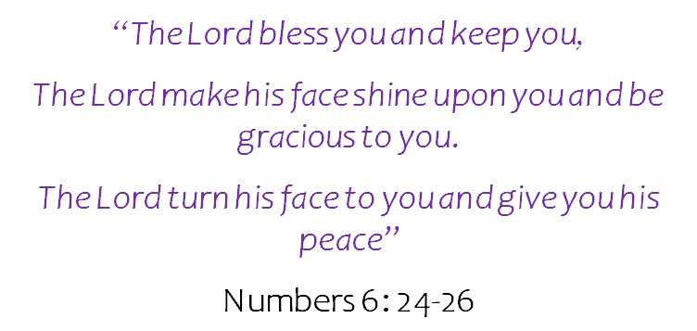

*Prayers include the Diocesan prayer for Ukraine and prayers from the Church of England website for different needs.*

**Loving God,**

**You hold all things in life and call us into Your kingdom of peace;**

**help us to walk the path of Your truth**

**and fill our lives with gratitude and faith,**

**through Jesus Christ our Lord.  Amen.**

Lord, pour out Your Holy Spirit upon us and may Your light so shine through us that together we share Your love with everyone and by Your power turn the tide of evil that surrounds us, through Jesus Christ our Lord. Amen.

***Diocesan Prayer for Ukraine***

Almighty God,

seated above all the affairs of humankind

and sovereign over nations and leaders, hear our prayer for Ukraine at this time of war, that lives may be spared, that national boundaries be respected and that forces of aggression be restrained.

Grant, Lord God, peace in Your world in our time. Through Jesus Christ our Lord. Amen.

This Prayer Letter is different from usual as John, our faithful Prayer Letter producer, is not well at this time – please do pray for John and his family, particularly for Sarah.

13th March 2022

***.”***

***FOR OUR MISSION WEEK***

**For growth and transformation**

Almighty God,  
in Christ You make all things new:  
transform the poverty of our nature by the riches of Your grace,  
and in the renewal of our lives make known Your heavenly glory;  
through Jesus Christ our Lord. Amen.

**Lord, we pray :**

For our Vicar Dave and our Curate Emma, and their families.

For Steve, Matt and every person working in the various activities in our Mission Outreach this week.

For all those who will hear about the love of God and the good news of Jesus this week – Lord, You change lives. Come, Holy Spirit.

For all who attend our church, that they are safe and renewed and know that you are the God of love, mercy, grace and forgiveness.

**For children and young people**

Loving God,  
Your Son told His disciples to become like little children.  
Lead us to work for the welfare and protection of all young people.  
May we respect their dignity that they may flourish in life,  
following the example of the same Jesus Christ our Lord. Amen.

***Lord, hear me as I pray;***

For the community of Devonshire Primary Academy: teachers, other staff, children, parents, grandparents and carers.

For all in our community whose lives are impacted by mental health difficulties, chronic pain, illness or disability.

For all in need of help with any personal, financial or social issues they are struggling to cope with at this time – That they may access the help and support they need to overcome their difficulties.

**Our Father in heaven,**

**hallowed be Your name, Your kingdom come, Your will be done,**

**on earth as in heaven.**

**Give us today our daily bread.**

**Forgive us our sins as we forgive those who sin against us.**

**Lead us not into temptation but deliver us from evil.**

**For the kingdom, the power, and the glory are Yours now and for ever. Amen.**

***Lord, hear me as I pray;***

For HM the Queen and all those who serve in our Government and those in local and devolved Government in the UK.

For all church leaders – give them wisdom, vision and strength.

For UK organisations and volunteers providing aid and assistance to refugees escaping from the brutal war in Ukraine.

Thank you, heavenly Father, for the love pouring out to Ukraine refugees in countries such as Poland, Slovakia, Hungary and across Europe.

*Everlasting God,  
at this time we lift to You  
those from all nations and backgrounds  
who work on the front line in healthcare.  
Give them skill and wisdom in their work.  
Be their strength and their shield as they give of themselves in the care of others. Amen.*

Heavenly Father,  
You are the source of all goodness, generosity and love.  
We thank You for opening the hearts of many to those who are fleeing for their lives.  
Help us now to open our arms in welcome, and reach out our hands in support, that the desperate may find new hope,

and lives torn apart be restored.  
We ask this in the name of Jesus Christ your Son, our Lord,  
who fled persecution at His birth and at His last triumphed over death. Amen