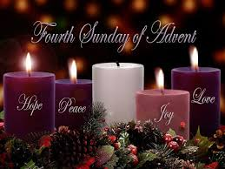
As this Newsletter is issued on the 4th Sunday of Advent and we wait and watch in hope to celebrate the coming of Christ as a baby in Bethlehem, let us remain prayerful and faithful to the One who is always faithful to us.

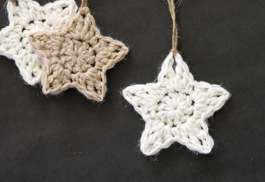
For those coming into church, you will have seen the Christmas tree in the front entrance decorated with Christmas baubles and lights and crocheted stars and cards. The Brew and a Chat group have crocheted the stars and attached the cards in memory of the loss of a baby or a loved one. Please see Nicola or Denise for more information and if you would like to put a star with its card on the tree.
Psalms for each day of the week 19th – 24th December:
Mon: Psalm 146 Tues: Psalm 46 Wed: Psalm 121
Thurs: Psalm 124 Fri: Psalm 130 Sat: Psalm 45
The services for the coming weeks are given below.
Key: DOB: Revd Dave O’Brien; SH: Revd Steve Haskett; VB: Vicky Bentley
Holy Communion Service of the Word

SUNDAY | 10.30am | 6pm
18th Dec  ADVENT 4 | Theme:  Matthew 1:  18 –25  Preach:  Archdeacon Mark Ireland  Lead: DOB | Service of the Word  7 Lessons and Carols  Gospel Presentation  Theme: John 1: 1 – 14  The Word made flesh  Preach:  Archdeacon Mark Ireland  Lead: DOB
SATURDAY  24th Dec  CHRISTMAS  EVE | MIDNIGHT COMMUNION  starting at 11.30pm  Theme: Luke 2: 1 – 14  Lead/Preach: DOB
SUNDAY  25th Dec  CHRISTMAS DAY | 10.30AM Service of Holy Communion  Theme: John 1: 1 – 14  Lead/Preach: DOB
SUNDAY  1st Jan 2023  Christmas 2 | 10.30AM Service of Holy Communion  Theme: Luke 2: 15 – 21  Lead/Preach: DOB
SUNDAY | 10.30am |  | 6pm
8th Jan  EPIPHANY/ BAPTISM OF CHRIST | Service of the Word  Theme:  Matthew 3: 13 – end  Lead: VB Preach: DOB |  | Holy Communion  Worship and Bible Teaching  Theme: Matthew 2: 1 – 12  Worship the King  Lead: DOB Preach: SH
Midweek Book of Common Prayer Holy Communion Service:
Will recommence in the New Year at 11am on Wednesday 4th January

PLEASE NOTE:
After today, the Newsletter and the Prayer Letter will be available again from Sunday 15th January 2023.

A blessed Christmas to everyone at St Thomas’ Blackpool and to all those who follow us on the church website and Facebook page.
May God direct us and give us vision, wisdom, strength and courage to act justly, love mercy and walk humbly with Him in 2023.

