

**Prayer Letter**

**5th and 12th February 2023**

* ***Lord of comfort and peace,***
* *we pray for all who are affected by the breakdown of family relationships, domestic abuse and divorce.*
* ***Lord of comfort and peace,***
* *we pray for all who are lonely and for all who are struggling with infirmity or pain in body, mind or spirit,* ***for Sarah, Leah, Debbie, Alison, Ted, Mary and Keith,Steve and Lisa, Norman and Jean, Anne and Ian and those who we know personally are suffering at this time.***

**Our Church Prayer**

Lord, pour out Your Holy Spirit upon us and may Your light so shine through us that together we share Your love with everyone and by Your power turn the tide of evil that surrounds us, through Jesus Christ our Lord. Amen.

* ***"The Lord bless you and keep you.***

***The Lord make His face shine upon you and be gracious to you.***

***The Lord turn His face to you and give you His peace."***

**Numbers 6: 24-26**

**3rd and 2nd Sundays before Lent**

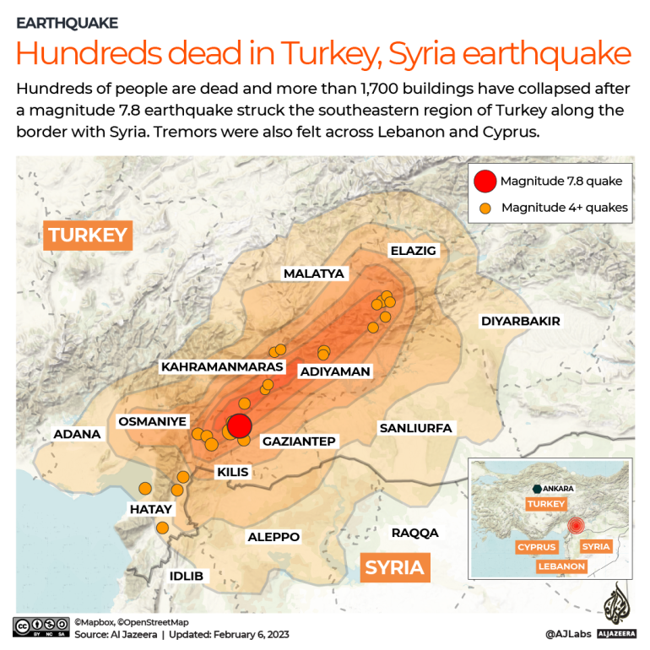 L

A prayer adapted from Lectio 365:

Living Saviour, as I consider the crisis in Turkey and Syria it’s easy to feel overwhelmed and helpless. Prayer seems inadequate but I don’t know what else to do and where else to turn. So, help me now to trust that You are making sense of the cries of my heart and that You are there with the rescue, recovery and aid workers and with all those who are injured and all those who are grieving. Amen.

***Lord hear us as we pray,***

**The Blackburn Diocesan prayer for Ukraine:**

Almighty God, seated above all the affairs of humankind and sovereign over nations and leaders, hear our prayer for Ukraine at this time of war; that lives may be spared, that national boundaries be respected and that the forces of aggression be restrained. Grant, Lord God, peace in your world in our time. Through Jesus Christ our Lord. Amen.

On the Diocesan website you will find a video with the Lord’s Prayer in Ukrainian. The Diocese will be holding a weekend of prayer for Ukraine, Friday - Sunday February 24 – 26, as that Friday marks a year since the invasion of Ukraine.

**for those people in the other areas of our troubled world** where conflict, poverty and famine are prevalent, and where so many cry out for justice and peace.

**for the people of Iran**, especially those who have been condemned to death and the families of those who have been brutally executed by the regime, simply for daring to protest for the freedoms and rights which we take for granted.

**for refugees and asylum seekers,** that they are treated with dignity, compassion and fairness within the law, wherever they seek refuge or asylum.

**PRAYERS FOR TURKEY AND SYRIA (taken from Lectio 365)**

Frontline workers on the ground are asking for prayer in 3 particular ways:

King of kings, I pray today in line with 1 Timothy 2: 2 for President Erdogan of Turkiye and al-Assad of Syria that their governments will cut through bureaucracy, leading courageously and granting free access to the aid agencies to serve on the ground.

God of shalom, in the chaos of this crisis I cry out for divine connections and a spirit of cooperation instead of competition. Would You streamline the important relationships between NGOs and suppliers, churches and other agencies for the sake of those who are suffering the most.

Holy Spirit, You who brooded over the formless void and created order, protect and provide for those who are grieving, those who are homeless, and those bringing emergency relief. I pray also for Your church in these ancient Bible lands. Anoint Your people at this time ‘to bring good news to the poor and …to bind up the broken hearted’ (Isaiah 61:1). In the name of Jesus, we pray, Amen.

***Lord hear us as we pray,***

for all Church leaders across our nation, and in our community. In our parish, for our Vicar Dave, for Alison and Josh.

for Steve and Lisa and for their ministry in our Church and elsewhere, especially for their work with the Life Association in India.

for Matt and Rosie and everyone involved in helping in Matt's ministry.

forThomasas he continues his placement with us.

for those who might be at our Church for the first time, that they may know God’s loving presence and peace and accept Jesus into their lives as their Saviour and Redeemer.

***Lord hear us as we pray,***

**For the General Synod of the Church of England** and the matters they have discussed this last week that affect the national church, all parishes throughout the country. **For those is positions of power** and leadership across our nation in national government, in parliament, in local councils, in devolved governments and the mayors of regions around our nation.

**For all who work in our emergency service workers** across our nation.

**For our NHS and Social Workers** at the front line of helping those suffering acute physical or mental health crises in our hospitals and in our communities.

***“And Jesus told them a parable to the effect that they ought always to pray and not lose heart”* ( Luke 18: 1)**

**For all Christians in Blackpool,** for unity among all who declare Jesus Christ is Lord. May the power of the Holy Spirit to inspire all believers to share the word of God and the love of Christ.

**For those who work especially in areas of conflict** or in places where there is severe personal danger for the good of others in our nation.

**Fore more workers of all backgrounds for the plentiful harvest fields** across Lancashire and for intercessors who are ambitious, insightful and who storm the gates of heaven.

***“For we are God’s handiwork, created in Christ Jesus to do good works, which God prepared in advance for us to do.”***

***Ephesians 2:10***