Praise and Worship evening
Friday 28th October in church starting at 7pm.
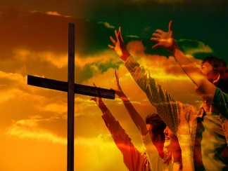
A time for us to come together to enjoy an extended time of worship and prayer, to give thankful praise to our God and to be open to His Holy Spirit for refreshing and direction.
Please do invite others along, especially those you know who you are praying for to come to know Jesus as their Saviour.

SUNDAY 30th October at 6pm
A special service to remember those we love who have died; an opportunity for prayer and reflection and to light a candle in memory.
Please do come to this service and invite others you know who have lost loved ones and allow God to pour out His comfort and peace.
Revelation 7: 17 – part of the scripture to be read at the service:
“For the Lamb at the centre of the throne will be their shepherd; ‘He will lead them to springs of living water.’ (Isaiah 49:10)
‘And God will wipe away every tear from their eyes’(Isaiah 25: 8)”

Psalms for each day of the week 24th – 29th October:
Mon: Psalm 98 Tues: Psalm 106 Wed: Psalm 111
Thurs: Psalm 115 Fri: Psalms 116, 117 Sat: Psalm 121

Information about the services for the next 2 weeks given opposite.
Key: DOB: Revd Dave O’Brien; VB: Vicky Bentley

Holy Communion Service of the Word

Prayers for healing
during the service

SUNDAY | 10.30am | 6pm
23rd Oct.  Last Sunday after Trinity | Luke 18:  9 – 14  Preach: DOB  Lead: DOB | Worship and Bible Teaching  Matthew 7: 7 - 12  Prayer  Preach: DOB  Lead: VB
30th Oct.  ALL SAINTS | Luke 19:  1 – 10  Preach: VB  Lead: DOB | Revelation 7: 9 – 17  Memorial/  Invitation Service  Remembering those we love  Lead: VB  Preach: DOB

Midweek (Wed.) Book of Common Prayer Holy Communion Service:

26th Oct. | Luke 18: 9 – 14 Lead/Celebrant: DOB Preach: VB

(the LORD said…) Now my eyes will be open and my ears attentive to the prayers offered in this place. (2 Chron, 7: 15)

