

***Lord, hear me as I pray;***

For our elected representatives in Parliament and on Blackpool Borough Council

For the community of Devonshire Primary Academy: teachers, other staff, children, parents, grandparents and carers

This week for all who live or work in Stirling Road, Stirling Court, Talbot Road and the Henthorne Street areas of our Parish

For all in our community whose lives are impacted by mental health difficulties, chronic pain, illness or disability

For all in need of help with any personal, financial or social issues they are struggling to cope with at this time – That they may access the help and support they need to overcome their difficulties.

***Lord, hear me as I pray;***

For our family members, our friends and colleagues in our places of work or education

ForSheila, Jack, Leah, Louise, Debbie, Nic and Joanne, Bob and Sue, Norman and Jean, Anne and Wendy

We also remember and pray for all those we know personally who are ill or struggling at this time in body, mind or spirit

For all who have recently been bereaved-That they may be given comfort and strength in their grief and loss.

***Prayer Letter***

***3rd Sunday before Lent***

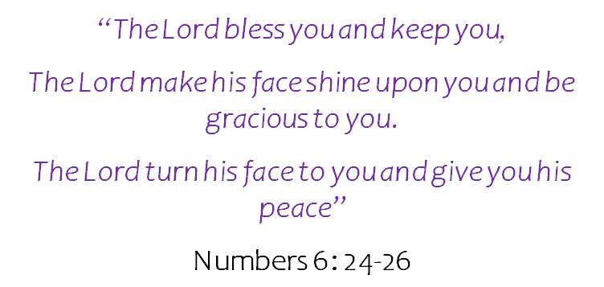

*“My eyes will be open and my ears attentive to every prayer made in this place”*

2 Chronicles 7: 15

***Lord, hear me as I pray;***

For our Vicar Dave and our Curate Emma

For Steve and Lisa for their overseas ministry in India and their work in our Parish

For Alison in her work with Ashar and for all those who are helped and comforted by her ministry

For our Church Warden, Pauline and all who help in welcoming people to our Church at each service

For Matthew our Children & Youth Worker

For our licenced Lay Ministers and for all at St Thomas'

For Joe and for all he does to coordinate the Church prayer tree network.

For Kathleen and those who volunteer with our Baptism Team.

For our Treasurer Chris and for all who serve on the Parochial Church Council

For volunteers working in the Church Office in their administrative work, and for all who give their time in so many different ways to support and enable the mission of our Church to continue and grow.

For all who attend our church, that they are safe and renewed and know that you are the God of love, mercy, grace and forgiveness.

13th February 2022

***.”***

***Lord, hear me as I pray;***

For HM the Queen, leaders in our Churches and in the Judiciary

For all who serve in national, devolved and local Government and also for Members of Parliament in Westminster & devolved administrations of Wales, Scotland and Northern Ireland

For all who serve in our armed forces and for their safety wherever and however they are deployed in protection of our nation and its people

For our Police, Fire and Rescue and Ambulance Services in the difficult and often dangerous situations they face. At this time, especially for the Metropolitan Police as it seeks to move forward under new leadership in command.

For volunteers in the life saving rescue services across our nation and its coastal waters

For our NHS frontline staff, Medical Scientists, Social Care Workers,

Social Workers and for all those they care for and for all who they help and protect through their work across each nation of the United Kingdom.

For all who teach, work or learn in our schools, colleges and Universities

For all whom produce or deliver goods and services to us which we rely on in our day to day lives and for those who work in leisure, sport and entertainment industries as their sectors seek to recover fully from the impact of the pandemic

For all who volunteer or work in supporting the most vulnerable in our society – This week especially for those who work or volunteer to help in food banks or with the homeless, and those in severe financial difficulties

For all who will be increasingly burdened by debt and poverty as daily essentials such as gas, electricity and food continue to increase greatly in price. For their protection from worry, anxiety and other health risks which may be increased due to the hardship they face.

***Lord, hear me as I pray;***

For your protection for all who are suffering religious persecution, threatened with torture and death simply for their Christian faith

That even at this late stage, diplomatic agreement will be found to prevent a catastrophic war in the Ukraine and other parts of Eastern Europe which could have implications for the entire world

Continually for the people of Afghanistan who are suffering from illnesses and high rates of infant mortality as preventative and curative medicines are no longer available – Especially for the 30 million people of Afghanistan, of all ages, who are now at serious risk of starvation and death

For the safety of all who are competing at the Winter Olympics in Beijing and that the games may be used as a means to unite the people of all nations in the hope of a peaceful world which may become free from war and the threat of war.

*“I urge, then, first of all, that petitions, prayers, intercession and thanksgiving be made for all people”*

1 Timothy 2:1

***Lord, hear me as I pray;***

For missionaries and Christians working with organisations and charities serving the poor, the sick, and the dying and those whose work restores health and brings hope to those most in need around our world

For the work of all organisations and charities promoting peace and security for the people of our world

For the work of charities which promote public awareness to end prejudice and discrimination towards people who live with a learning disability, and also for those whose work or volunteering helps people with learning disabilities to lead rewarding and fulfilling lives.